DOI: 10.2507/36th.daaam.proceedings.xxx

Title of Paper (Times New Roman, 18 pt bold,
Capitalize First Letter)

Branko Katalinic, Hong Seok Park & Mark Smith (14 pt)

 |  | 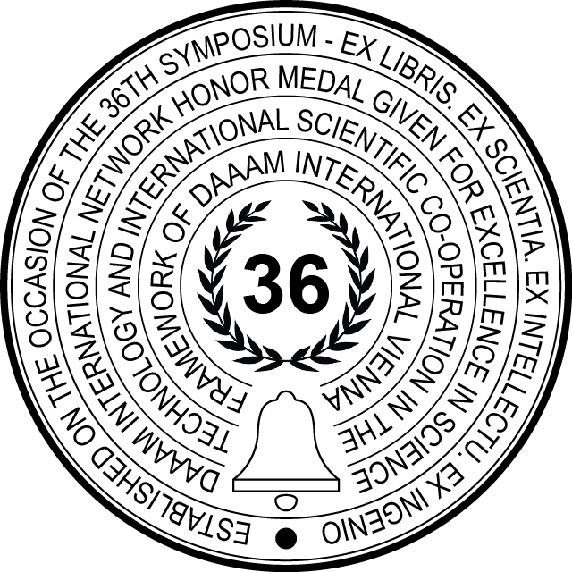

This Publication has to be referred as: Katalinic, B[ranko]; Park, H[ong] S[eok] & Smith, M[ark] (2025). Title of Paper, Proceedings of the 36th DAAAM International Symposium, pp.xxxx-xxxx, B. Katalinic (Ed.), Published by DAAAM International, ISBN 978-3-902734-xx-x, ISSN 1726-9679, Vienna, Austria
DOI: 10.2507/36th.daaam.proceedings.xxx

Abstract

Abstract of 70-200 words (10 pt). Write a short abstract of the paper not exceeding 200 words. It should indicate subjects dealt with in the paper and the main objectives of the investigation. The abstract should be complete in itself, readers should not have to read the whole paper to understand the abstract.

Keywords: (10 pt) Separate your keywords by semicolons; Keywords have to be suitable, clear, concise, adequate and accurate.

- Introduction (Pt 10, bold)

Use DIN A4 Format (297 x 210 mm). All margins: top, bottom, left and right are 20 mm each. Use Times New Roman fonts, line spacing single, justified. The paper must be written in English. The paper has to be saved in .docx format.

Each paper must give clear answers on 5 - What questions:

- What is the problem (problem statement)?
- What have been done by other people (literature - critical overview)?
- What have I done (research course, method used, and technical solutions)?
- What are new (results / technical solutions)?
- What to do as next (further research)?

Use words rather than symbols or abbreviations when writing. Avoid leaving a heading at the bottom of the page, with the subsequent text starting at the top of the next page. Generally known abbreviations such as CAD, CAM, FEM, and dc, do not have to be defined. Do not use abbreviations in the title or heads unless they are unavoidable.

The title of the paper has to be suitable, clear, concise, and accurate. Not too long - not too short

  - Language (pt 10, italic)

Use common technical terms. Do not try to create new English words.

  - Bulleted list (pt 10, italic)

Bulleted lists should look like this:

- First
- Second
- Third…

  - Tables

Number all the tables with Arabic numerals (1,2,3…). The table number and caption have be typed below the table with font size 10 pt and centre justified. Every table should be centre justified. The text in the table should be size 10 pt, unless there is a need for a smaller font size. There should be an empty line (pt 10) before and after each table. Here is a table example:

Column Heading | Column A | Column B
P1 | 1 | x
P2 | 2 | y
P3 | 3 | z
P4 | 4 | s

Table 1. Table example

  - Paper size

Minimum paper size is 3 (Three) full pages and the maximum paper size is 10 (Ten) pages.

- Figures

Figures have to be made in high quality, which is suitable for reproduction and print. Check photos and colour prints on the quality of black white reproduction. Text and explanations on the figures must be readable. The figures have to be placed as close as possible to the first reference to them in the paper.

Number all the figures with Arabic numerals (1,2,3,….). The figure number and caption have be typed below the figure with font size 10 pt and centre justified. Every figure should be centre justified. If there are more figures that need to be next to each other, use a hidden table with the appropriate number of cells for alignment. All figures have to be aligned with the text (Format figure - Wrap text – Align with text). There should be an empty line (pt 10) before and after each figure.

All figures have to have a minimum 300 DPI resolution. Low-quality scans or low quality screenshots are not acceptable. The text and shapes have to be clearly visible and readable. Papers with low quality figures will be rejected.

Fig. 1. Figure example
- Equations

Use the hidden table with two columns for alignment, as shown in example:

$a^{2}+b^{2}=c^{2}$ | (1)

There should be an empty line (pt 10) before and after each equation. Be sure that the symbols in your equation have been defined before or immediately following the equation. Use “(1)”, not “Eq. (1)” or “equation (1)”, except at the beginning of a sentence: “Equation (1) is …”.

- DAAAM guidelines for paper preparation

There are people who are ready and want to help you to present results of your research in the best possible way to the international scientific community. Those nice people are our reviewers. They will review your paper and will suggest improvements. The main target of their work is to help you make your paper better. Their suggestions are following some basic ideas and questions. We are giving here in chaotic order some of their typical ideas, advices and questions. Please take care about these facts, and your ideas, results and paper will be much better presented to the international public.
      - The title of paper has to be suitable, clear, concise, and accurate.
      - The abstract has to reflect the content of paper accurately and has to bring out the main points of paper. Abstract has to be specific and representative of the article, and the motive for the research has to be indicated. It should state concisely the goals, methods, principal results, and major conclusions of the paper. Abstract is not short introduction in the field.
      - Does the Introduction concisely put the study into a larger context, including core references? Is the purpose of the study and question(s) clearly stated? Is the specific context (e.g. research environment) clear? Is the reader well prepared for the methods and results sections? Is the introduction clear and relevant to the aim of the study?)
- Is the conclusion significant? Is it just a rehash of the paper? Does it provide new synthesis or insights? Does it leave the reader excited about the research, the research domain or the future? The conclusions have to be accurate and supported by the content in a logic order.
- Are the cited references relevant and recent? Are all important references included? Is the correct referencing format used? Please use strictly DAAAM Instructions for Authors for references!
- The research has to be properly ground in the literature. Use important, current and adequate citations. What is with review of the existing research literature on this topic?
- Are all parts of the article interesting, or are there any parts that can be shortened or deleted?
- The writing has to be clear concise and interesting. English spelling and grammar. Consider the three guidelines for successful communication - to be clear, concise, and correct. Use direct, straightforward, and unambiguous words and phrases. Unusual abbreviations, scientific jargon and acronyms need to be avoided. Composition and language: (How does the article read? Does it read well? How is the use of grammar in the article?)
- All figures, tables, and photos have to be necessary and appropriate.
- Make balance between figures, equations and text.
- The author has to provide adequate motivation.
- Describe and explain clearly the purpose and aim of the study / the research the article: (Who is the target audience? What is the article attempting to accomplish?)
- The author has to provide adequate background information.
- The literature review and research study methods have to be explained clearly.
- Please describe and explain clearly the approach of the study/the research. Orient your research to previous concepts and research.
- The author has to cover everything promised in the introduction. The author has to express thoughtfully the limitations of the research and the author's approach. Explain the question at issue addressed by your article: (Is the article trying to figure something out, settle a question or solve a problem?)
- Explain the point of view of this article: (Which position or theoretical perspective is the article presenting?)
- Identify the major concepts and ideas presented in this article: (How are terms defined? What are the theories, principles, or models used?)
- Identify the implications and/or consequences of the ideas presented in this article: (What would happen if these ideas were accepted or implemented? Consider both positive and negative outcomes.)
- Explain clearly: What do the researchers want to find out? Why is that important to investigate or understand? How are the researchers investigating this? Are their research methods appropriate and adequate to the task? Please describe clearly and concisely method used. Describe clearly your research strategy.
- Present your results clearly in a logical sequence which supports the research target. Interpretation of results: Are the results interpreted correctly, sufficiently discussed and compared with results of other studies? Is the problem solved? Is the research question answered?
- Describe your future research plans. Where the research described in this paper will lead and what the next step will be?
- Conclusion

Please prepare your paper and data exactly according to the instructions. That is the easiest and the most efficient way to have: a good published paper, clear presentation and successful symposium.
Conclusions should state concisely the most important propositions of the paper as well as the author’s views of the practical implications of the results. Be brief and give most important conclusions from your paper. Do not use equations and figures here.

- Acknowledgments

Please write here if your paper is a result of research in the frame of: cooperation, one grant or other public, private, national or international project. Here you can thank to the people and institutions. Put here also sponsor(s) acknowledgements. Acknowledging the contributions of other colleagues who are not included in the authorship of this paper is also added in this section. If no acknowledgement is necessary, this section should not appear in the paper.

- References

Please note that all references listed here must be directly cited in the body of the text. When referenced in the text, enclose the citation number in square brackets, for example [1]. All references in the text have to be cited individually, for example [1], [2], [3] etc…
DAAAM International published thousands of papers from many different fields. Citing from DAAAM published papers (2024, 2023, 2022, 2021, 2020), Scientific Book and IJSIMM is obligatory. Please find the citation relevant papers in DAAAM bibliography. Use the following steps:
- Find the papers with keywords from your field of interest
- Download the full papers using the DOI link
- Study the papers from the viewpoint of citation suitability
- Integrate suitable papers in your paper references by copy / pasting the prepared referencing data from the DAAAM bibliography
Papers that have not been published, even if they have been submitted for publication, should be cited as “unpublished” [8]. Papers that have been accepted for publication should be cited as “in press” [9]. Capitalize only the first word in a paper title, except for proper nouns and element symbols. For papers published in translation journals, please give the English citation first, followed by the original foreign-language citation. Examples for different references: Books references [1]; Proceedings paper references [3]; Web document references [6]; Journals paper references [11]; Reports and Theses [12] and [13].
Important: Better to cite too often than not often enough. Self-referencing of all authors of your paper must be less than 50 % of references. Minimal number of references is 8.

[1] Alabar, B.; Kusiak, A. & Nanasi, J. (2021). Name of Book, Publisher, ISBN, Place of Publication
[2] Katalinic, B.; Park H. S. & Udiljak T. (Year). Name of Paper, Available from: http://www.exact-address-of-site Accessed: YYYY-MM-DD
[3] Kataumo, B.; Kusiak, A. & Nanasi, J. (Year). Title of conference paper, Proceedings of xxx xxx, conference data, location, ISSN, ISBN, Katalinic, B. (Ed.), pp. 14-17, Publisher, City, DOI
[4] Kusiak, A. (Year). Name of paper. Name of Journal, Vol., No., (month and year of the edition) page numbers (first-last), ISSN
[5] Ueda, K. & Kusiak, A. (Year). Name of paper, In: Name of Book, Name(s) of Editor(s), (Ed.), page numbers (first-last), Publisher, ISBN, Place of publication
[6] http://www.insse.ro, (Year). The National Statistics Institute, Statistics Year Book, Accessed on: 2021-08-13
[7] Filaretov, V. & Adamczak, S. (Year if known). Title of paper, unpublished.
[8] Grabenweger, J.; Tabucanon, M. & Schmidt, P. (Year if known). Title of paper with only first word capitalized, Journal Name Standard Abbreviation, in press
[9] Bleicher, F.; Kittl, B. & Durakbasa, N. M. (Year). Balanced Manufacturing, IFT - Vienna University of Technology, Report, unpublished
[10] Schmid, J., Jones, B. & Braun, J. (2018). The title of the journal paper”, Journal Name, Vol. 24, No. 11, pp. 1872-1880., ISSN, DOI
[11] Nagla, K. S.; Jones, B.; Torims, T. & Brown, J. (2016). Title of the report, Company/Lab name, Identification code if any
[12] Takakuwa, S. T. (2016). Title of the thesis, Ph.D. Dissertation, Department, University, City, Country

